Cape Elizabeth Town Council Workshop
Agenda Monday, October 2, 2017
7:00 p.m.
Town Hall – Council Chambers

James M. “Jamie” Garvin, Chairman
Patricia K. Grennon
Caitlin R. Jordan
Penelope A. Jordan
Sara W. Lennon
Katharine N. Ray
Jessica L. Sullivan

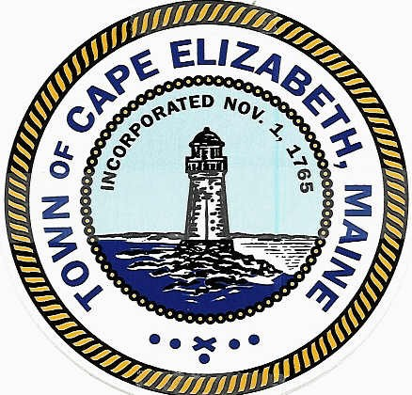

Participation at Meetings and Conduct of Meetings

Workshop Meetings

The purpose of a workshop meeting is primarily for council dialogue involving reports and proposals from council members, committees and staff that may be considered at later Town Council meetings. The Town Council may give guidance to the chairman and to staff at workshop meetings but no decisions may be made that require formal votes. Not withstanding the prior sentence, the Town Council may vote on procedural motions at a workshop meeting to determine a conflict of interest, to enter into executive session and to adjourn. Prior to Town Council discussion on any item, members of the public may speak on each agenda item for not more than three minutes each and up to a total of 15 minutes. If there are more speakers than the time available, the chairman may allocate the speaking time in order to balance the debate. The public participation portion shall conclude when the Town Council begins its discussions.

Decorum

Persons present at Council meetings shall not applaud or otherwise express approval or disapproval of any statements made or actions taken at such meeting. Persons at Council meetings may only address the Town Council after being recognized by the chairman.

Convening by Town Council Chairman James M. “Jamie” Garvin

- The town council will continue the paper street discussion on Surfside Avenue, Atlantic Place and Lighthouse Point Road.

Link to Durwood Parkinson Letter Dated 7/19/2017
Link to Durwood Parkinson Letter Dated 9/13/2017

- A new position of park director for Fort Williams Park was discussed at the 9/18 workshop with the Fort Williams Park Committee. The council will continue to review the recommendation.

Link to Draft Park Director Duties

- Consideration of a standing renewable energy committee was recommended in the report of the ad-hoc Alternative Energy Committee. It was a consensus at the 5/1 council workshop that language be drafted in the format of the boards and committees ordinance for future council review.

Link to Draft Renewable Energy Committee Charge

- Chairman Garvin will present a recommendation to move the regular November 13 council meeting to November 8.

Adjournment

