Town of Cape Elizabeth
Town Council Workshop Agenda
Wednesday, October 16, 2013
6:30 p.m.
Cape Elizabeth Town Hall

1. Draft 2013 Greenbelt Plan

The Town Council and Conservation Commission will review the draft 2013 Greenbelt Plan.

THE TOWN COUNCIL WILL HOLD A SITE WALK PRIOR TO THE WORKSHOP.

The site walk will be held at 5:00 p.m. Town Councilors should meet at the end of Pilot Point Rd, and can park on Pilot Point Rd.

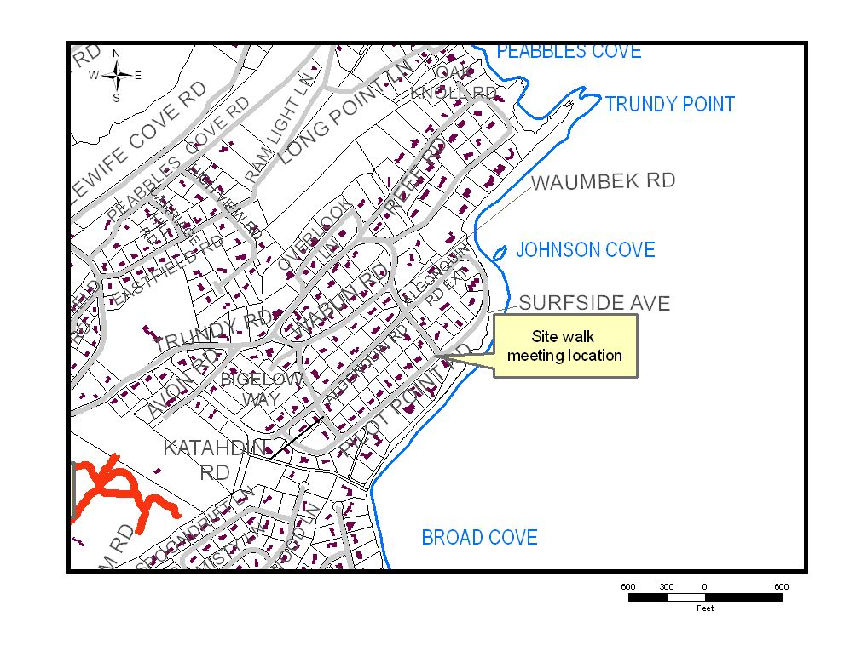
Public Participation at Town Council Meetings
After an item has been introduced, any person wishing to address the council shall signify a desire to speak by raising their hand or by approaching the lectern. When recognized by the chairman, the speaker shall give his or her name and address or name and local affiliation, if the affiliation is relevant, prior to making other comments. All remarks should be addressed to the Town Council. Comments shall be limited to three minutes per person; however, the time may be extended by majority vote of councilors present. For agenda items that are not formally advertised public hearings, the time for public comments is limited to 15 minutes per agenda item. This time may be extended by a majority of the Town Council. The chairman may decline to recognize any person who has already spoken on the same agenda item and may call on speakers in a manner so as to balance debate. Once the Council has begun its deliberations on an item, no person shall be permitted to address the Council on such item.

Speaking at the meeting on topics not on the agenda at regular Council meetings
Persons wishing to address the Council on an issue or concern local in nature not appearing on the agenda may do so at a regular Town Council meeting before the town manager’s report and/or after the disposition of all items appearing on the agenda. Any person wishing to address the Council shall signify a desire to speak by raising their hand or by approaching the lectern. When recognized by the chairman, the speaker shall give his or her name and address or name and local affiliation if the local affiliation Council. Comments in each comment period shall be limited to three minutes per person and 15 minutes total; however, the time may be extended by majority vote of councilors present.

Decorum
Persons present at Council meetings shall not applaud or otherwise express approval or disapproval of any statements made or actions taken at such meeting. Persons at Council meetings may only address the Town Council after being recognized by the chairman.

